**Problem Statement**

**Product Dissection for top leading Platforms**

Welcome to this case study on dissecting and designing products for top leading platforms. In this case study, you will delve into the intriguing world of schema design for a prominent platform of your choice. Your task is to choose a top leading platform, research its features, and meticulously craft a schema design that encapsulates the essence of its functionality. By focusing on key entities, attributes, and relationships, you will gain invaluable insights into how data architecture drives the platform's effectiveness.

**Step 1: Choose a Leading Platform**

Select a leading platform of your choice, which could span various domains such as social media, e-commerce, finance, or any other industry. This choice will form the foundation of your exploration into its schema design.

**Step 2: Research:**

Thoroughly research the platform you have selected. Investigate its core features, functionalities, and user interactions. Identify the top features that define its user experience and contribute significantly to its popularity.

**Step 3: Product Dissection and Real World Problems solved by the platform**

In this step, you will meticulously analyse the platform's standout features and how they provide innovative solutions to real-world challenges. By identifying key functionalities that resonate with users, you'll unravel how the platform effectively addresses problems and enhances user experiences. This dissection will serve as the foundation for understanding how the schema design aligns with the platform's core objectives.

**Step 4: Case Study on the real world problems and approach to solving them**

In this pivotal step, you will expand on the real-world challenges uncovered in Step 3 through a comprehensive case study. Delve into specific instances where users encountered difficulties and showcase how the platform's unique features provided effective solutions. By dissecting the approach taken by the platform to overcome these challenges, you'll gain a deeper appreciation for the platform's user-centric design philosophy and how it shapes the schema design.

**Step 5: Schema Design Based on Top Features**

Based on the features you have identified, craft a schema design that reflects the platform's data structure. Focus on the key entities, attributes, and relationships that underpin the chosen features. Your schema should capture the essence of how the platform organises and utilises its data.

**Step 6: Rationale Behind the Design**

While creating the schema design, consider the rationale behind the platform's choices. Reflect on why certain entities and relationships were chosen and how they align with the platform's goals. This will help you understand the strategic decisions driving the schema's architecture.

**Step 7: Create an ER Diagram**

Utilise tools like the Miro platform or similar applications to create an illustrative Entity-Relationship (ER) diagram. This diagram should vividly depict the entities, attributes, and relationships present within your schema design. The ER diagram will serve as a visual representation of your insights.

**Step 8: Presentation of Findings**

Present your findings in a clear and concise manner. Showcase your understanding of how the schema design impacts the platform's functionality and user experience. Explain how your chosen features are integrated into the schema and how the schema's structure supports the platform's objectives.

**Task Details:**

1. **Answer Submission:** Your submission should include well-structured solutions for all provided questions related to product schema designs.

1. **Video Creation:** Create an informative and engaging video where you thoroughly explain the Case Study.

1. **Depth and Clarity:** Ensure your solutions are detailed and showcase your understanding of product schema design principles. Similarly, in the video, provide clear explanations that are easy to understand for a wide audience.

1. **Creativity Encouraged:** You are welcome to utilise visuals, diagrams, or creative elements to enhance the clarity and impact of your explanations.

**Note:**

1. Duplicate this document and proceed to write your solutions and prepare your video.
2. Include the video link in this document before final submission.

Best of luck in completing this project and showcasing your prowess in dissecting and designing product schema for leading platforms! **For reference, we have also conducted a case study on Instagram, which you can find below. This case study will provide you with valuable insights into how schema design plays a pivotal role in shaping the functionality and success of a prominent platform.**

—------------------------------------------------------------------------------------------------------------------------------

Video Link :- [ _ ]

—------------------------------------------------------------------------------------------------------------------------------



### **Product Dissection for Telegram:**

Company Overview: Telegram, founded in 2013 by Pavel Durov and Nikolai Durov, has emerged as a leading messaging platform that prioritizes privacy, security, and user control. With a steadfast commitment to offering a messaging service free from advertisements and data mining, Telegram has gained a loyal user base globally. Known for its encryption protocols and innovative features, Telegram has redefined the standards for secure communication and real-time messaging.

### **Product Dissection and Real-World Problems Solved by Telegram:**

Telegram stands out as a messaging platform that addresses real-world challenges through its robust privacy features and seamless communication tools. By prioritizing end-to-end encryption, secret chats, and self-destructing messages, Telegram ensures that user conversations remain confidential and secure. This focus on privacy addresses concerns regarding data privacy breaches and unauthorized access, providing users with a safe space to communicate without compromising their personal information.

The platform's innovative features, such as channels, groups, and bots, enhance user interactions and facilitate seamless communication among individuals, communities, and businesses. Telegram's emphasis on user control and customization allows users to tailor their messaging experience to suit their preferences, ensuring a personalized and efficient communication environment. Moreover, Telegram's cross-platform functionality and cloud-based architecture enable users to access their messages seamlessly across devices, enhancing convenience and accessibility.

In conclusion, Telegram's product design effectively tackles real-world problems by offering a secure and feature-rich messaging platform that values user privacy, control, and seamless communication. Through its commitment to innovation and user-centric design, Telegram has established itself as a trusted messaging service that empowers users to connect, collaborate, and communicate in a secure digital space.

### **Case Study: Real-World Problems and Telegram's Innovative Solutions:**

Telegram has carved a niche for itself in the messaging landscape by addressing significant real-world challenges and providing innovative solutions through its platform.

### **Problem 1: Data Privacy and Security Concerns:**

**Real-World Challenge:** In an era where data breaches and privacy violations are prevalent, users seek secure communication channels that safeguard their sensitive information.

**Telegram's Solution:** Telegram prioritizes user privacy by implementing end-to-end encryption across all messages, ensuring that only intended recipients can access the content. Additionally, the platform offers secret chats with self-destructing messages, adding an extra layer of security for confidential conversations. By addressing data privacy and security concerns, Telegram establishes itself as a trustworthy platform that values user confidentiality.

### **Problem 2: Seamless Communication Across Devices**

**Real-World Challenge:** Users often switch between multiple devices throughout their day, leading to fragmented communication experiences and inconvenience.

**Telegram's Solution:** Telegram's cloud-based messaging architecture enables seamless synchronization of messages across devices, ensuring that users can access their conversations from smartphones, tablets, and desktops without interruption. This feature empowers users to stay connected and engage in conversations seamlessly, regardless of the device they are using, enhancing convenience and user experience.

### **Problem 3: Community Engagement and Collaboration**

**Real-World Challenge:** Communities and businesses require efficient tools to engage with their audience, facilitate communication, and foster collaboration.

**Telegram's Solution:** Telegram offers channels, groups, and bots as tools for community engagement and collaboration. Channels allow users to broadcast messages to a large audience, enabling businesses to share updates, news, and content effectively. Groups facilitate interactive communication among members, fostering discussions and collaboration. Bots automate tasks, provide information, and enhance user experience within the platform. By providing these features, Telegram empowers communities and businesses to engage with their audience and enhance communication efficiency.

**In summary**, Telegram's innovative solutions effectively address real-world challenges related to data privacy, seamless communication across devices, and community engagement. By prioritizing user privacy, offering cross-device synchronization, and providing tools for community collaboration, Telegram has positioned itself as a leading messaging platform that meets the diverse communication needs of users and organizations in today's digital landscape.

### **Top Features of Telegram:**

1. **Secret Chats:** I love how Telegram offers end-to-end encrypted secret chats. It gives me an extra layer of security for my sensitive conversations. I can even set self-destruct timers on my messages, so the content disappears after a certain time. It's really handy for keeping things private.
2. **Channels:** Telegram Channels are great for sharing news, updates, and content with a large audience. It's so easy to broadcast messages to all my subscribers and keep them engaged.
3. **Groups:** The Telegram Groups feature is fantastic for interactive communication and collaboration with others. I can pin important messages, reply directly to people, and use the moderation tools to keep discussions focused. It's perfect for teamwork and building communities.
4. **Bots:** Telegram's bot platform is really impressive. I can use all kinds of AI-powered automated services right within the app - things like getting information, running polls, receiving notifications, and integrating with other apps. It's super convenient.
5. **Cloud Storage:** The free cloud storage for my media and files is a game-changer. I can access all my content across my devices without worrying about local storage limits. It makes my life so much easier.
6. **Customization:** I love being able to customize my Telegram experience with themes, stickers, and emojis. It lets me express my own style and personality in the app.
7. **Voice and Video Calls:** The high-quality voice and video calling on Telegram is fantastic. It's so handy for connecting with friends, family, and colleagues in real-time. The secure and reliable calls are a big plus.
8. **Multiplatform Support:** It's great that Telegram works seamlessly across my smartphone, tablet, and desktop. I can switch between devices and always have access to my conversations and media.
9. **Photo & Video Editing:** The built-in editing tools are awesome. I can quickly enhance my photos and videos with filters, stickers, drawings, and captions before sharing them. It makes my content look so much better.
10. **File Sharing:** The fast and secure file sharing is incredibly useful. I can send all kinds of documents, photos, videos, and other files up to 2GB in size. It's so convenient for exchanging information.

Overall, Telegram has become an essential part of my daily communication and productivity. The features make my life so much easier and more connected. I highly recommend it!

### **Schema Description:**

Telegram's schema encompasses various entities that capture different facets of the platform's functionalities and user interactions. These entities include Users, Chats, Messages, Channels, Bots, Files, and more. Each entity is defined by specific attributes that detail its characteristics and relationships with other entities.

**User Entity:** Users are fundamental to Telegram's ecosystem, with the user entity containing essential user information:

* **UserID (Primary Key):** A unique identifier assigned to each user.
* **Username:** The user's chosen username for identification.
* **Phone_Number:** The user's phone number for account association.
* **Full_Name:** The user's complete name as displayed on their profile.
* **Bio**: A brief description that users can use to share additional information.
* **Registration_Date**: The timestamp indicating when the user joined Telegram.

**Chat Entity**: Chats facilitate conversations and interactions between users:

* **ChatID (Primary Key):** A unique identifier for each chat.
* **Participant_UserIDs**: References to the users participating in the chat.
* **Type**: Specifies the type of chat (e.g., individual chat, group chat).
* **Creation_Date**: The date when the chat was initiated.

**Message Entity**: Messages contain the text, media, and other content exchanged within chats:

* **MessageID (Primary Key):** A unique identifier for each message.
* **ChatID (Foreign Key referencing Chat Entity):** The chat to which the message belongs.
* **Sender_UserID (Foreign Key referencing User Entity):** The user who sent the message.
* **Content**: The text, media, or file content of the message.
* **Timestamp**: The time the message was sent.

**Channel Entity**: Channels serve as broadcast platforms for disseminating messages to a wide audience:

* **ChannelID (Primary Key):** A unique identifier for each channel.
* **Creator_UserID (Foreign Key referencing User Entity):** The user who created the channel.
* **Description**: Information about the channel's purpose and content.
* **Subscribers_Count**: The number of users subscribed to the channel.

**Bot** **Entity**: Bots are automated accounts that perform various functions within Telegram:

* **BotID (Primary Key):** A unique identifier for each bot.
* **Username**: The username assigned to the bot for interaction.
* **Description**: Details about the bot's capabilities and services.
* **Token**: Authentication token for the bot's API access.

**File Entity:** Files represent media and documents shared within chats and channels:

* **FileID (Primary Key):** A unique identifier for each file.
* **File_Type**: The type of file (e.g., image, video, document).
* **File_URL**: The URL link to access the file.
* **Upload_Date**: The date when the file was uploaded.

**Relationships**:

* **Users engage in Chats** – Users can participate in multiple chats, including individual and group chats.
* **Chats contain Messages** – Chats can have multiple messages, and each message is associated with a specific chat.
* **Users create Channels** – Users can create multiple channels for broadcasting messages to subscribers.
* **Bots perform Actions** – Users can interact with multiple bots, and each bot can provide various services and responses.
* **Chat Messages include Files** – Messages can include various files (media, documents) shared within chats.
* **Users can be Organizers or Members of Channels** – Users can create channels or subscribe as members.

By defining and interconnecting these entities, Telegram's schema captures the complex network of user interactions, communications, and content sharing that form the foundation of the platform's messaging ecosystem.

### **ER Diagram:**

Let's construct an ER diagram that vividly portrays the relationships and attributes of the entities within the Telegram schema. This ER diagram will serve as a visual representation, shedding light on the pivotal components of Telegram’s data model. By employing this diagram, you'll gain a clearer grasp of the intricate interactions and connections that define the platform's dynamics

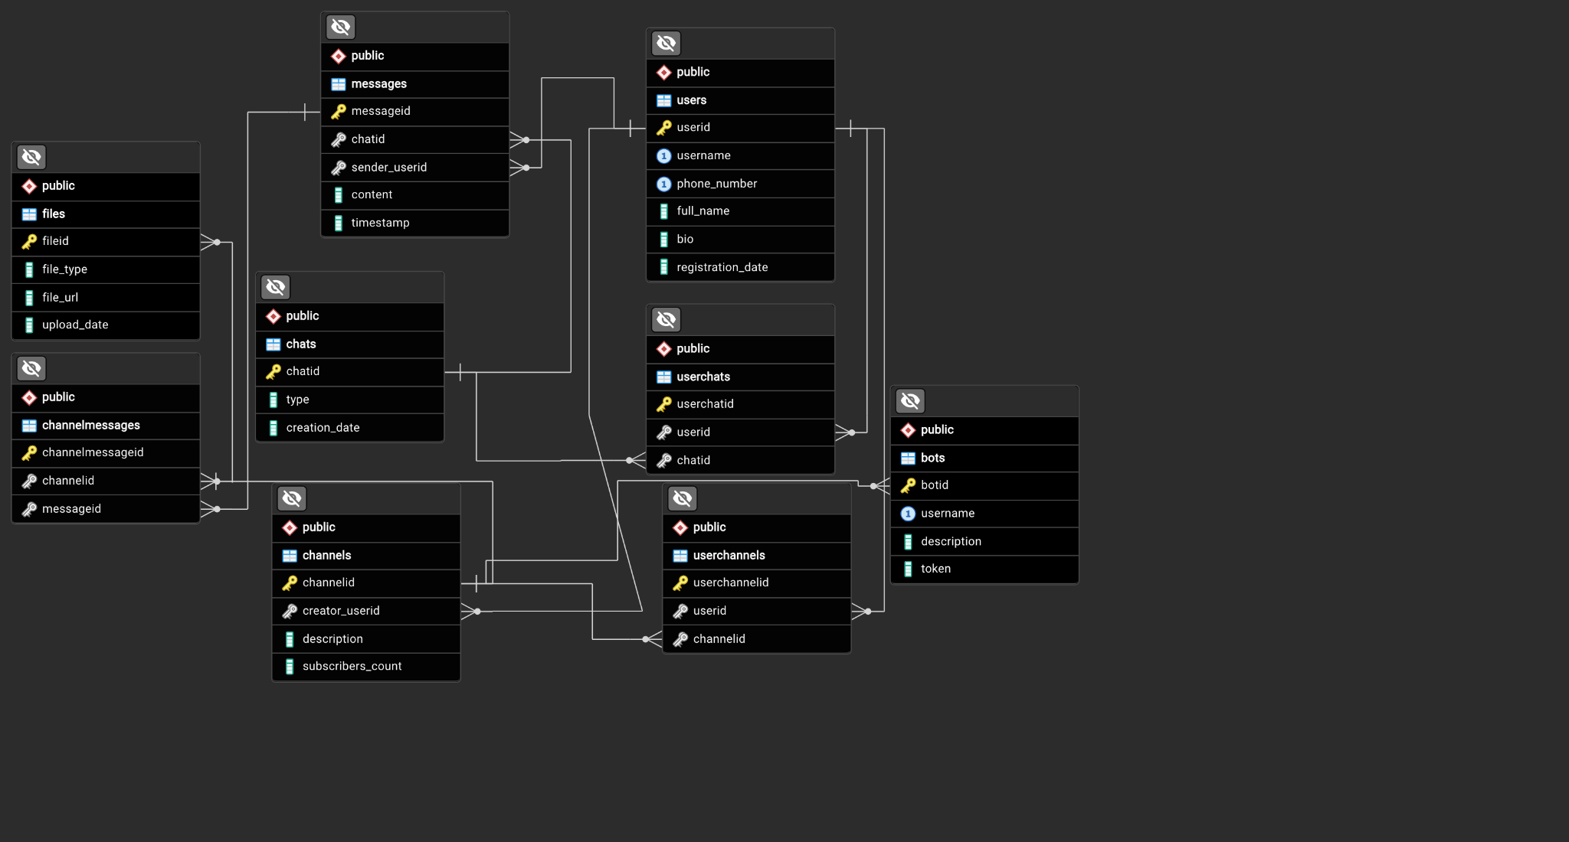

### **Conclusion**

In this case study, we explored the design of a database schema for a Telegram-like application using SQLAlchemy. By defining tables for users, posts, media, followers, comments, and favorites, we established the structural framework necessary for facilitating user interactions and content sharing within the application. The relationships between these entities enable the platform to manage user-generated content effectively and cultivate engagement among users. Through the generated Entity-Relationship diagram, we gain a visual representation of how data flows within the application, showcasing the interconnected nature of its components. This database schema sets the stage for a dynamic and interactive platform akin to Telegram, where users can connect, share media, and engage in meaningful conversations seamlessly.